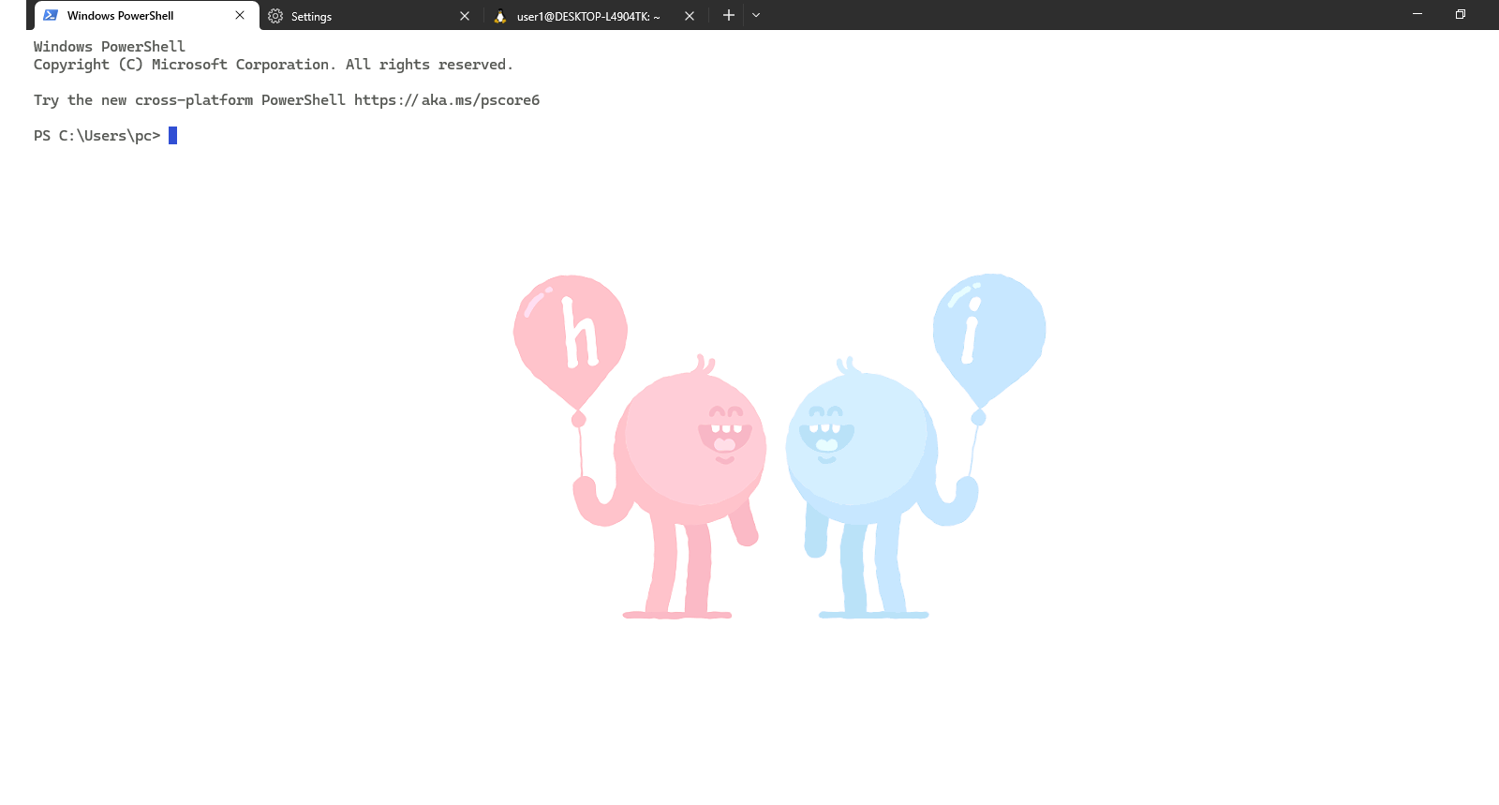Diansa Quach

Linux and Apache Project

**Customization of Terminal:**

Cmd/ Command Prompt Designs:

* Wallpaper Background Image

Animated Graphics Interchange Format (GIF)

"backgroundImage": "C:\\Users\\pc\\Downloads\\Linux\\animatedhi.gif",

"backgroundImageOpacity": 0.3,

"backgroundImageStretchMode": "none",

* Colour Scheme Theme

"colorScheme": "Tango Light",

* Mouse Pointer/ Cursor

"cursorColor": "#314FD4",

"cursorShape": "filledBox",

* Font:

"Cascadia Code"

Ubuntu Designs:

* Wallpaper Background Image

Animated Graphics Interchange Format (GIF)

"backgroundImage": "C:\\Users\\pc\\Downloads\\Linux\\animatedhello2.gif",

"backgroundImageAlignment": "center",

"backgroundImageOpacity": 0.3,

"backgroundImageStretchMode": "uniformToFill",

* Colour Scheme Theme

"colorScheme": "One Half Light",

* Mouse Pointer/ Cursor

"cursorColor": "#00E600",

"cursorShape": "vintage",

* Font

Consolas

* Directory

"startingDirectory": "C:\\Users\\pc\\Desktop\\Linux and Apache",

